**Chapter 2**

**Different parts of the software**

**Briefly about Paydar San’at Shadegan Company**

Paydar San’at Shadegan Company was registered on 2003 the 26th of August with a credit amounting to one million Rials. This company started its activity in 2004 with a two-class school located in Shadgan city, until now it has been able to successfully complete many huge projects and provide valuable services to the people of Shadgan.

One of the successfully completed projects is the construction of 150 cubic meters of air resources in Shadgan Mansoura with a credit of 1,363,227,000 Rials (one billion, three hundred and sixty three million, two hundred and twenty seven thousand Rials). The duration of this project is 4 months, from 29/06/2008 to 30/10/2008.

Another project that this company has successfully carried out is the provision of manpower for the cleaning of Payam Noor Shadgan University, which was carried out from 21/06/2008 to 05/03/2009 with an amount of 250000000 (two hundred and fifty million Rials) to receipt completion.Accounting principles in simple language

**Accounting headings**

The most fundamental part of an organization is the accounting system, because in this part all the definitions of the system are made in the form of accounting headings. The initial definition of the accounts and their logical connection, forms the organization information structure.

Accounting headings have a tree structure. Usually a three-level tree as follows:

Figure 2-1 Accounting Headings Tree

**In Accounting the above tree can have infinite levels, but these three levels usually are sufficient. For example:**

Figure 2-2 Sample hierarchical accounting headings tree

Accounting headings have the type and account group. The account group means which group each heading belongs to, current assets, fixed assets, income, etc. In addition to that what is meant by the type of the account is the nature of each following heading:

1. Debtor
2. Creditor
3. Debtor/Creditor

It should be mentioned that an accounting heading can be without group and type.

**Accounting Documents**

It can be said that accounting documents are among the principles of learning accounting. Each accounting document consists of four columns. (Figure 1-2)

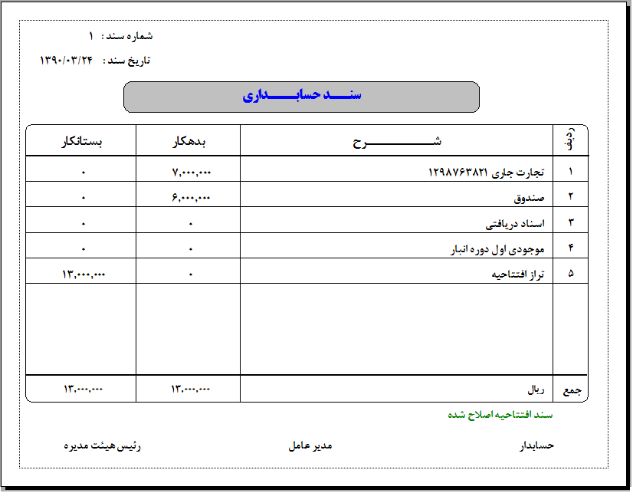

Figure 2-3 sample of an Accounting document

1. **Row Column:** In this column the row number is inserted.
2. **Description Col.:** In this lies the description/heading of the cost.
3. **Debtor Col.:** Here lies the debtor amount.
4. **Creditor Col.:** Here lies creditor amount.

In addition to this four columns, each accounting document have a column called sum (last column), in which the sum of the two columns, debtor and creditor, is placed.

All accounting books are derived from accounting documents. That is, by creating accounting documents, you can obtain a journal, general ledger, specific and detailed ledger from these documents.

**Journal Ledger**

All the daily events of the company or organization are recorded in the journal. In fact, by creating an accounting documents and putting them together (sorted by date) you can create a journal ledger. According to Article 7 of Iran's Commercial Law, a journal ledger is a book in which a businessman must record his daily claims, debts, commercial transactions and transactions related to commercial papers. In general, all his commercial imports and exports (regardless of name) and funds which he withdraws for his personal expenses to record in it.

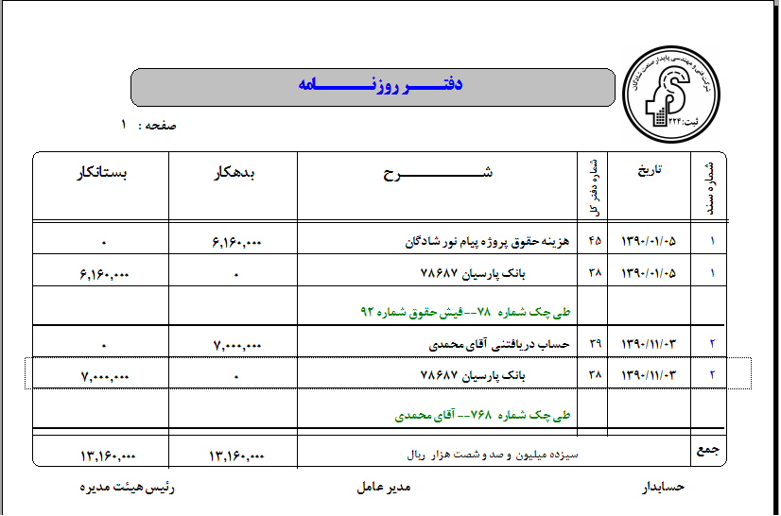

Figure 2-4 an example of a Journal Ledger

As you can see, the newspaper office has following columns:

1. **Document Number:** Shows the unique number of the document.
2. **Date:** Shows the date of the accounting document.
3. **Ledger number:** Number of heading related to subsidiary.
4. **Description:** Description of the document along with its related subsidiary heading.
5. **Debtor:** Debtor amount related to a row which is displayed in the book.
6. **Creditor:** Creditor amountrelated to a row which is displayed in the book.

The journal should have appropriate columns to transfer the accounting document information to it. Therefore, the journal should at least have columns for entering the accounting document number, date, description, debit amount and credit amount of each event.

**General Ledger**

A ledger is a book in which accounts are kept separately after being classified. These accounts may be in the form of pages of a book or in the form of cards or free papers.

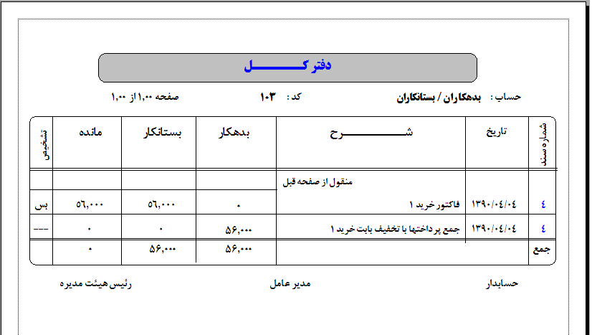

Figure 2-5 General Ledger

**General ledger is consists of:**

**Account title:** At the top of the page the title of the headings related to this book is displayed.

**Code:** Account code related to the heading of this book.

**And also columns as follows:**

1. **Document Number:** Document number registered for transactions.
2. **Date:** Date of the registered document or transactions done.
3. **Description:** Description of event done.
4. **Debtor/Creditor:** Debtor or creditor amount of the event.
5. **Remain:** Sum of remain column of general ledger
6. **Detect:** detection of type of the current row.

**Subsidiary Ledger**

In some institutions, the work flow is in such a way that it is necessary to prepare special information with details of some financial activities. This kind of information cannot be easily extracted from the general ledger, as a result, the offices that have an auxiliary and subsidiary aspect and are called the designated office are used. A specific ledger is maintained for each general ledger account that includes multiple and separate accounts, and as a result, the corresponding account in the general ledger will be a control account, the balance of which always corresponds to the sum of the balances of the corresponding account in the specific ledger.

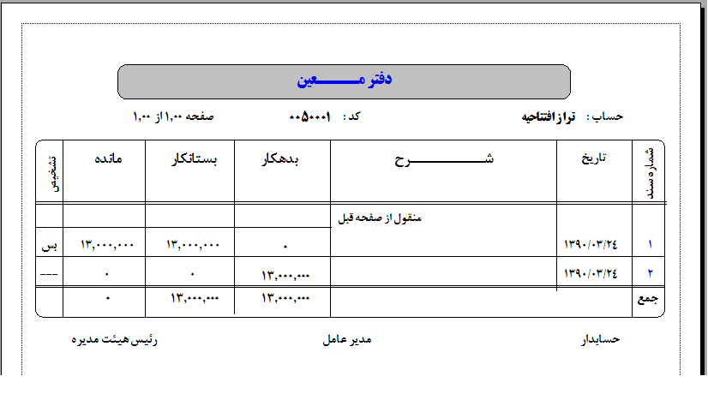

Figure 2-6 Subsidiary Ledger

**The columns of subsidiary ledger are identical with general ledger.**

**Trial Balance Sheet**

The trial balance is a list of the balances of the general ledger accounts, and this list is usually prepared at the end of each month, and it assures the accountants of the equality of the items transferred to the general ledger and the correct balancing of the accounts.

The trial balance is not part of the official accounting documents, it is usually written in pencil so that any mistakes can be easily corrected. There are two types of trial balance; two columns and four columns.

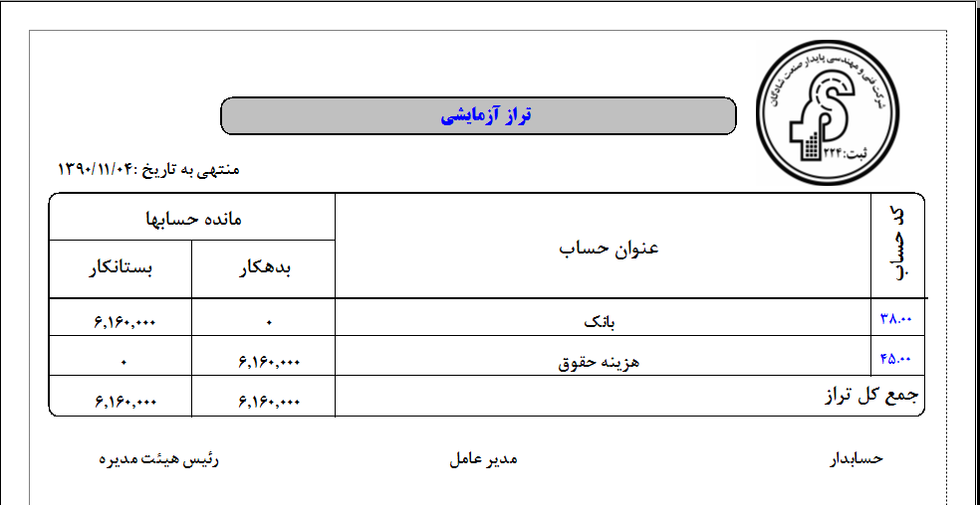

Figure 2-7 Two-column Trial Balance sheet

The two-column trial balance is prepared as follows:

1. **Step 1:** Write a trial balance title at the top of the page.
2. **Step 2:** Transfer the transactions to the trial balance; next to the name of each account, the balance of each account is written in the debtor or creditor column of the trial balance.
3. **Step 3:** Balance test of the Trial Balance; after the balance of all accounts is transferred to the trial balance, the balance of the trial balance is tested in the following order.

* Draw a line under the debtor and creditor columns
* Calculating and writing down the sum of two columns

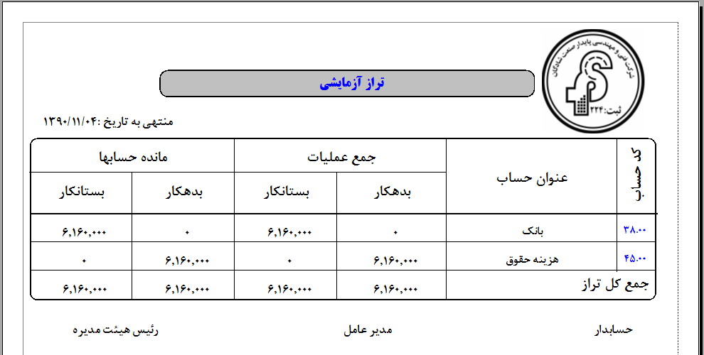

Figure 2-8 Four-column Trial Balance

In the four-column trial balance, the operation sum column has also been added.

**Balance Sheet**

The balance sheet is a form that shows the financial status of an institution on a certain date (usually the last day of the month or year) and for this reason it is also called the financial status. The balance sheet is actually the same accounting equation in which the figures related to each of the two sides of the equation are separated and displayed with detailed classification. In other words, the balance sheet shows the assets and liabilities of an institution.

The title of the balance sheet consists of three lines, the first line is the name of the institution whose balance sheet is prepared to show its financial status, and the name of the prepared financial statement, which is the balance sheet, is mentioned in the second line. In the third line, the balance sheet preparation date is written, which is usually a certain day, and this means that the balance sheet shows the financial situation of the institution on a certain day and not in a financial period. In addition, the balance sheet shows the financial status of an institution and not the personal financial status of the owner or owners of the institution because they may have other sources of income.

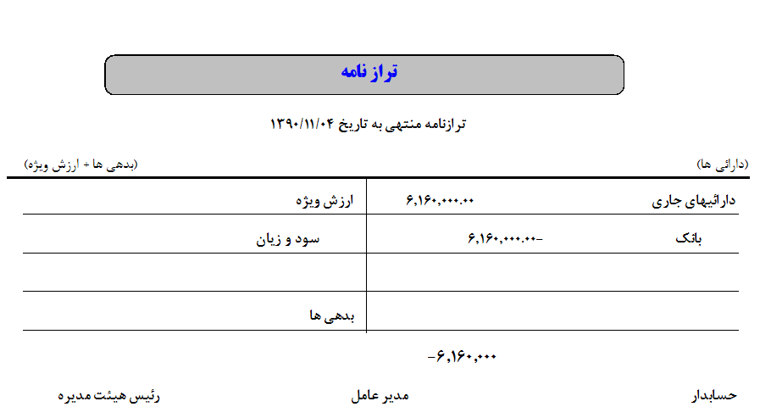

Figure 2-9 Balance Sheet

In the form of the balance sheet report, the title of the balance sheet consisting of three lines is given first. Then we bring the assets in the form of a column, after that the liabilities are written, and after that we bring the owners' rights of the capital account.

In general, it can be said that the balance sheet is the form that provides the necessary information about the payment of the institution's debts.

**The** **Database**

The most important part of an application is the database. In fact all the operations done on an application are based on the database. A database which is designed by considering all conditions and contains comprehensive number of fields, increases the sufficiency of the process.

**Accounting Documents (AccountingDocs)**

One of the most important and crucial tables in the software is the Accounting Documents table.

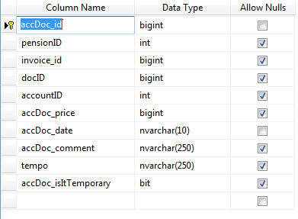

In this table the Accounting Document itself is stored. Accounting documents fields are:

1. Accounting Document No. (Key-Field)
2. Accounting Document Date
3. Accounting Document Fee
4. Accounting Document Description
5. Accounting Document Type (Permanent or Temporary)

An Accounting Document have following properties:

1. Row number
2. Chart of accounts code
3. Charts of accounts title
4. Description
5. Debtor
6. Creditor

We should consider each one of these properties as individual field. Thus in order to store an Accounting Document’s rows there is a need for another table:

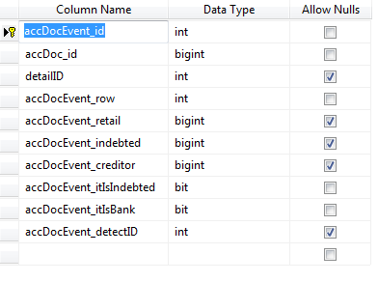

This Table is used for storing Accounting Document’s rows. In fact an accounting doc can have an infinite number of rows thus the relationship between these two tables is 1 to ∞.

To create this relation we have to use AccDocc_id field:

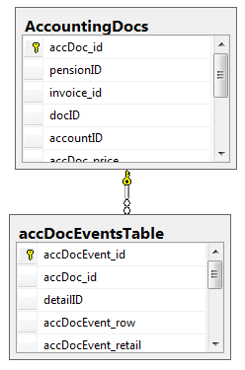

**Implementing Accounts Headers (SpentMaster, DetailsTable)**

As mentioned earlier, one of the Accounting document statistics is charts of accounts. These Headings are:

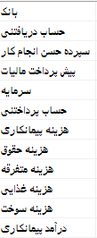

These Titles are the super (upper level) titles. It means these title have their own subset titles which called subsidiary titles.

We stored the super titles in a table with a name “SpentsMaster”:

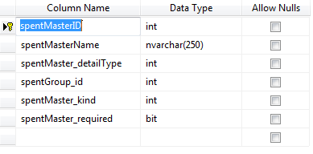

The Key-Field as the figure describes is named spentMasterID. By using this key, we create a one-to-many relation into subsidiary table. This table is as follows:

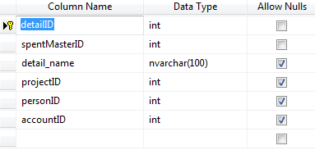

The relation is as follows:

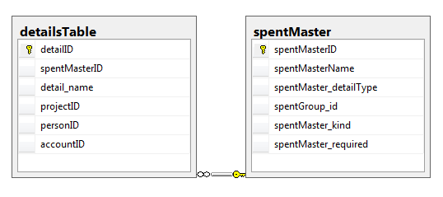

**Bank Accounts (AccountsTable) and Cheques (ChecquesTable):**

Banks accounts of contact companies are stored in Bank_Account table and cheques are stored in cheques-related table.

**Bank Accounts:**

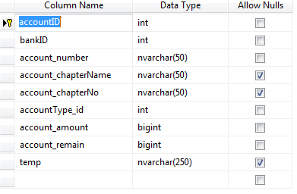

The key field of this table is accountID. There is a field named BankID in this table which is foreign key. This field creates a relation between banks and table of bank accounts. It is obvious that each bank can have multiple account. For example I have to accounts in two different banks. The banks table is as follows:

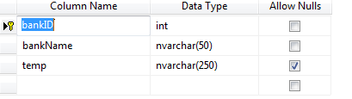

Information of this table are pre-entered and the end-user only allowed to append to them:

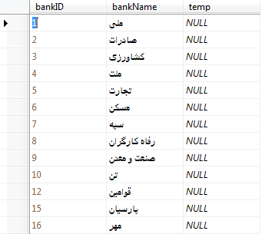

**Cheques table is as follows:**

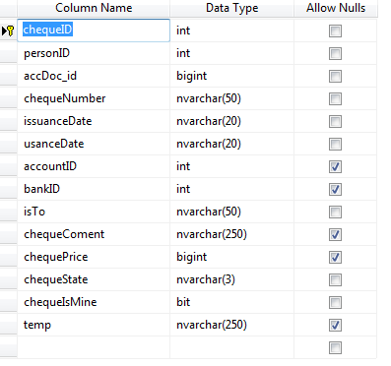

As it demonstrated cheques table is in relation with three table at a time:

* Accounting Documents Table
* Persons Table
* Bank Accounts Table

Therefore it cannot be in relationship with the above tables at the same time. The relation of four banks, bank’s accounts, cheques and persons is as follows:

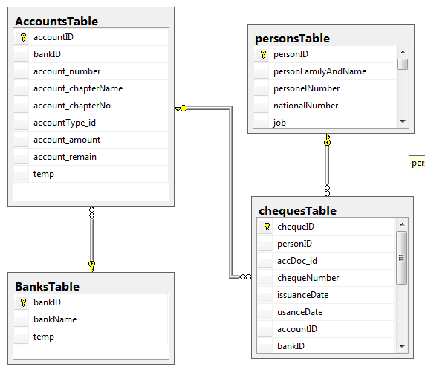

**Salary Paper (pensionsTable):**

Salary receipt papers are been delivered to the employees and workers in an active project.

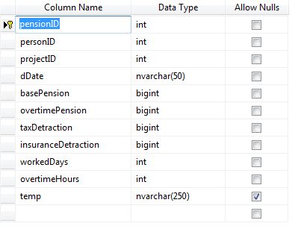

The Key-Field of this table is pensionID. For each salary receipt can define Benefits and deductions. It means each salary receipt can have infinite number of them. These items are used to calculate the pure salary of each employee and worker. The table in which Benefits and deductions are store is as follows:

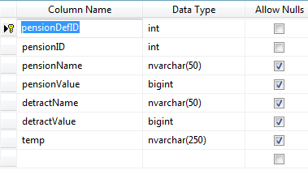

The two pensionName and pensionValue fields are used to define Benefits whereas detractName and detractValue are used for deductions definition.

It is certain that the relation between these latest mentioned tables is created with pensionID.

